Hipaa Insurance Auditing

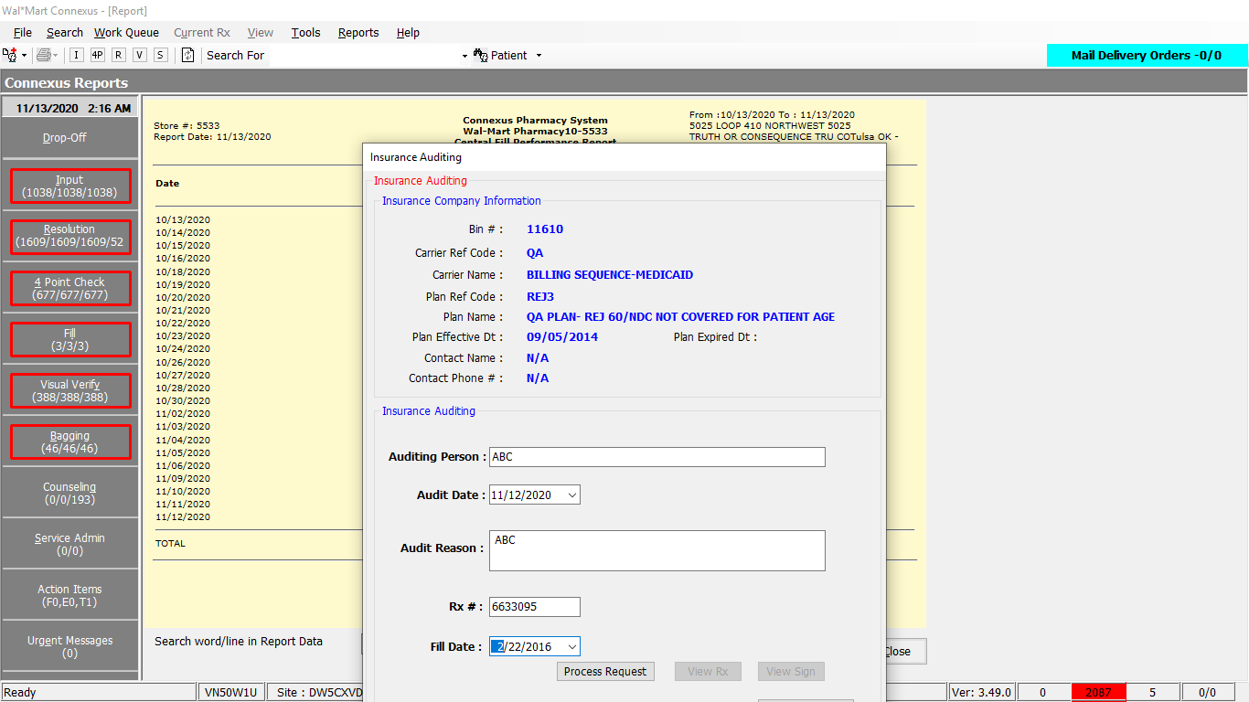

On button click of process request it tries to found the data from DB. If data exists It will show below screenshot

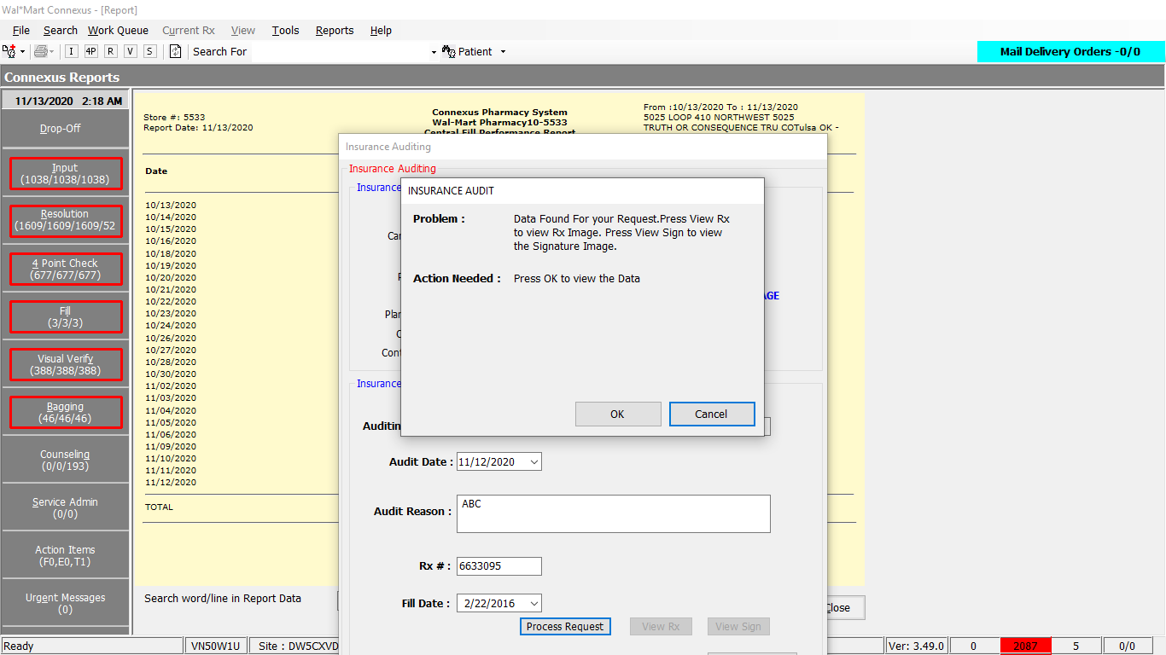

Once after clicking on OK button it inserts the Details into database by using InsertReportTransactionLog service.

Based on response from DB ViewRx/Viewsign buttons will be enabled

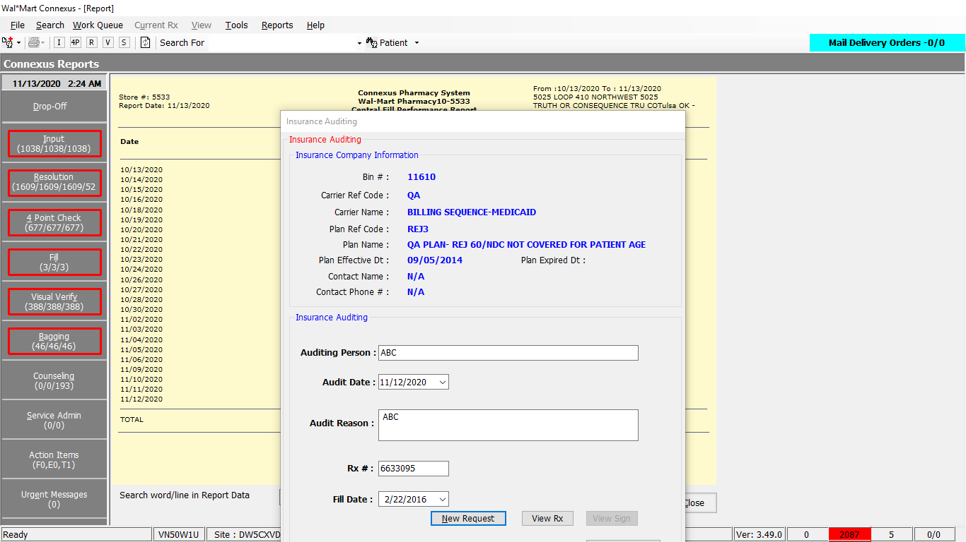

On button click of ViewRx/ViewSign its trying to load imageview getting below screenshot

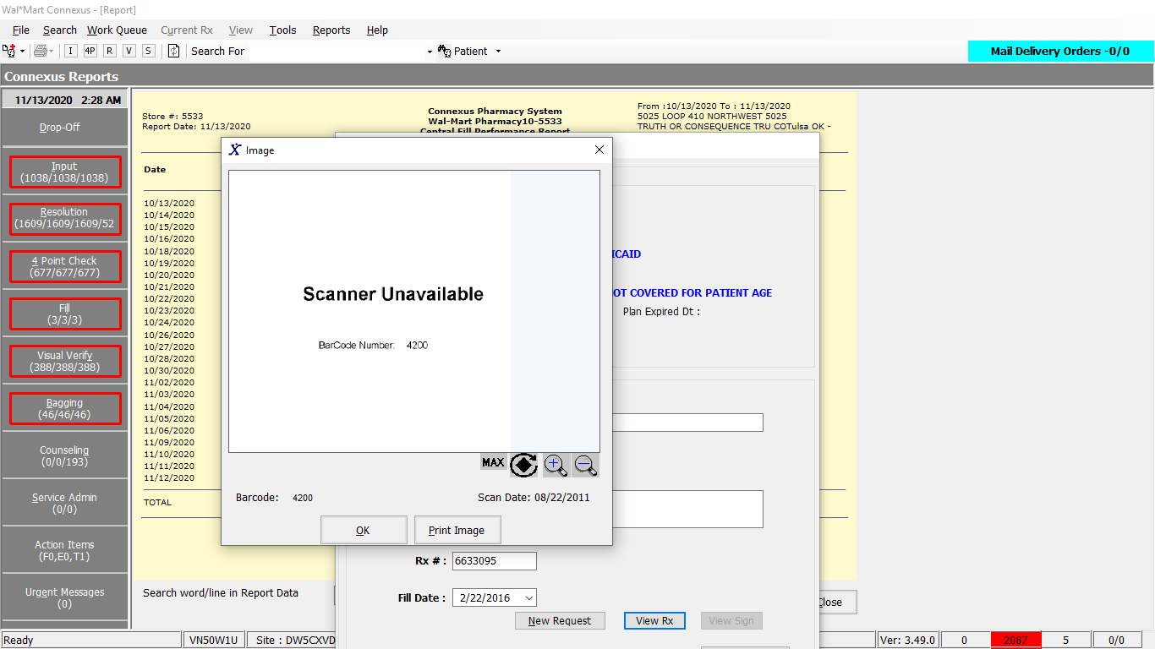

When I try to print

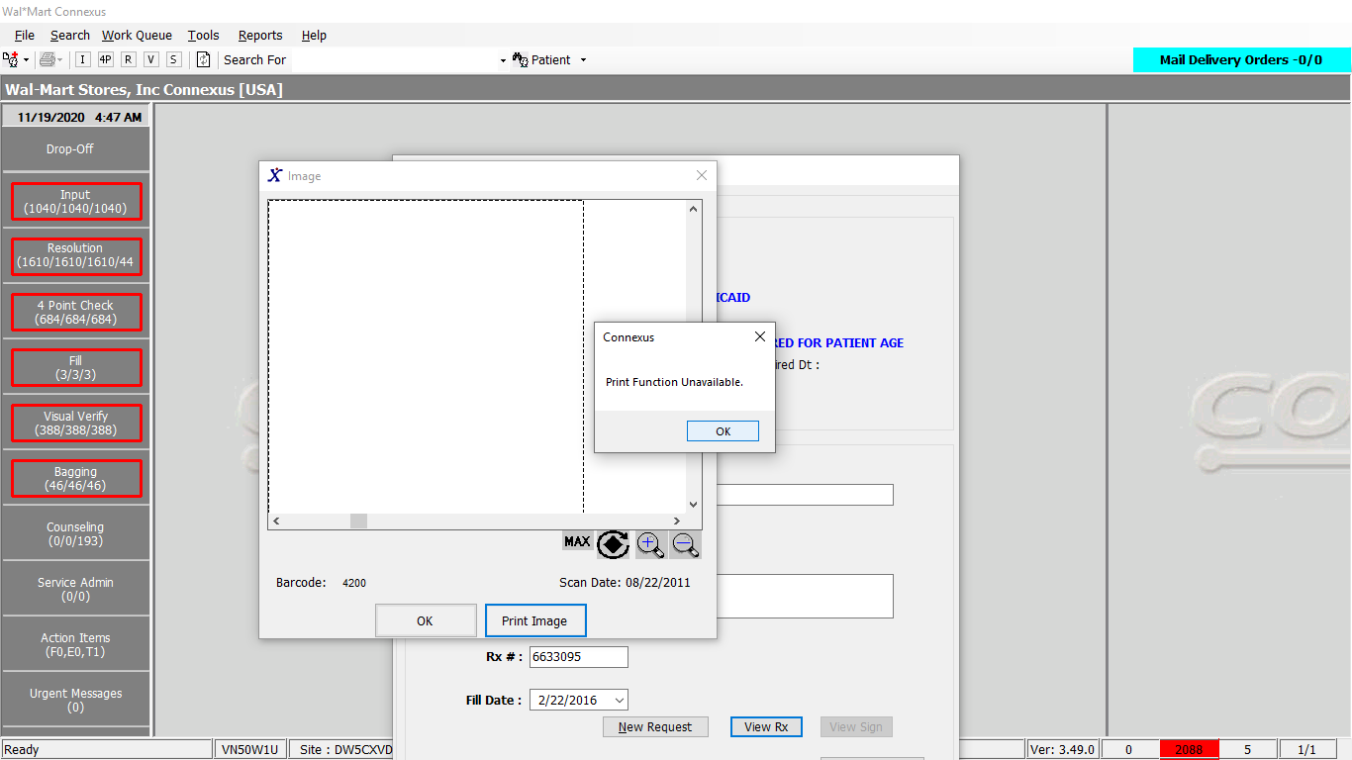

And tried giving some dummy imageId as hardcoded parameter that time getting below screen

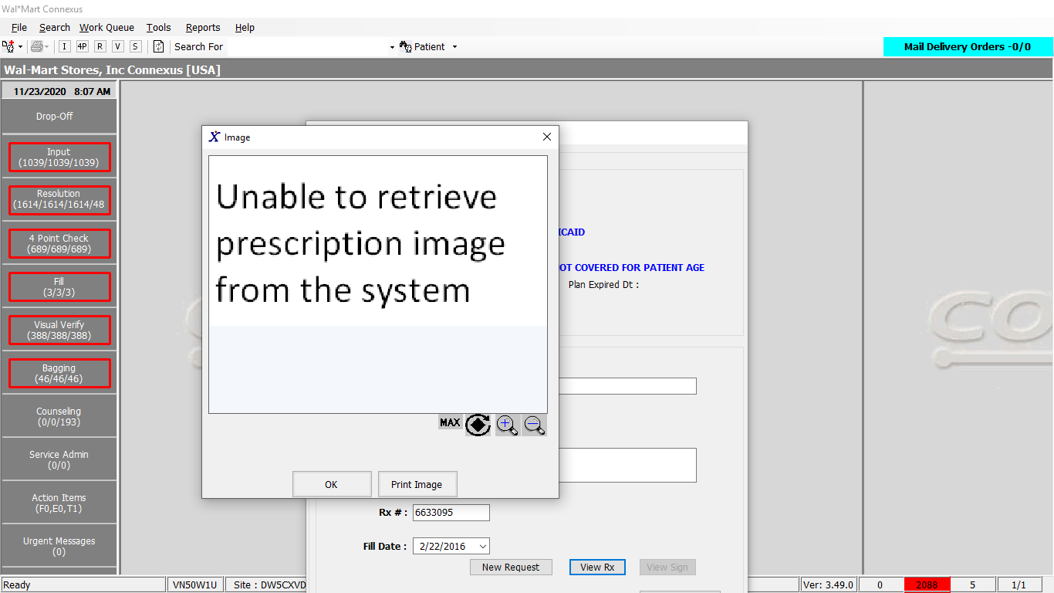

Conclusion : There is no Response screen for Hipaa insurance auditing report. It is trying to show only particular image type as shown in above Screenshots